PRIVATE 24/1715 ISAAC WHITFIELD HUNTER
NORTHUMBERLAND FUSILIERS

24th (Service) Battalion (1st Tyneside Irish) 1914 – 1916
24th Divisional Cyclist Company (Army Cyclist Corps) Sep-Dec 1915
10th (Service) Battalion Northumberland Fusiliers 1916
25th (Service) Battalion (2nd Tyneside Irish) 1916 -1917

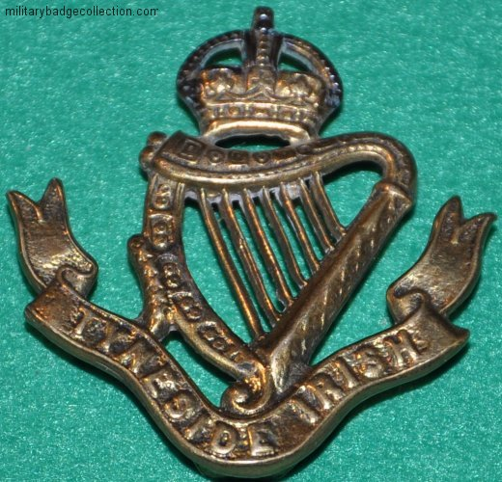

The Specially Designed ‘Tyneside Irish’ cap badge of the Northumberland Fusiliers
Isaac Whitfield Hunter was born in Chevington, Northumberland in 1897. His parents were John George Hunter and Mary Langley. In 1901, aged 4, he lived with his family at 234, Titchfield Terrace, Pegswood, Northumberland. When he was 14 years old he was employed as a miner at Netherton Colliery near Bedlington, Northumberland. Isaac had nine siblings, four sisters and five brothers. Family records show that two of his brothers also served in the Great War and survived. His brother John James Hunter, Private 10807, enlisted in the Northumberland Fusiliers and then joined the East Yorkshire Regiment. Isaac’s other brother, George Edward Hunter, Acting Sergeant 6223, also joined the Northumberland Fusiliers. Research shows it’s very possible they all enlisted on the same day in 1914.
Isaac enlisted as ‘Isaac Hunter’ at Newcastle-on-Tyne into the 1st Tyneside Irish Battalion, one of six Tyneside Irish “Pals” battalions drawn from local Newcastle men who had Irish connections. The six Tyneside Irish Battalions (and six additional Tyneside Scottish battalions) were raised in Newcastle by the Lord Mayor and City between November 1914 and June 1916. Isaac was aged 17 years and his occupation was coal miner.

After his initial training in March 1915 at Woolsington near Newcastle, they joined 103rd Brigade, 34th Division at Ripon North Yorkshire in June 1915 and then moved to Salisbury Plain in late August for final training. It had taken over a year to bring the battalion and other sister units of the 34th Division up to the required standard after suffering delays in providing it with sufficient equipment, arms and ammunition stocks.

In September 1915, the 42nd Divisional Cyclist Company was formed on Salisbury Plain from men (possibly volunteers) of the 24th Northumberland Fusiliers. to be the 34th Division’s reconnaissance troops. Information (from Graham Stewart, author of “The Tyneside Irish) has a note that Hunter No- 24/1717 became a member of this unit. However Isaac’s medal card shows that he disembarked in France still as a member of the Northumberland Fusiliers (January 1916 according to the records of the 24th Battalion) so he either asked to go back or was not cut out for fast cycling work.

Embarkation orders arrived in 3 Jan 1916 for the whole Division to move to France and entrainment began on 7th January to embarkation ports and by the 15 January the 34th Division was concentrated around La Crosse (East of St. Omar). Isaac’s records show him as disembarking in France as a member of the 24th Battalion Northumberland Fusiliers. This regiment was incorporated into the 103rd (Tyneside Irish) Brigade and were engaged in the infamous Battle of the Somme, commencing on 1st July 1916. Isaacs’s records show he was possibly one of those less seriously wounded and spent some time at a rear hospital recovering after the first day of the offensive. Following this Isaac was involved in the following actions.

25 – 28 September 1916: The 23rd Division engaged in the Battle of Morval, a continuation of the Somme Battles. The 10th Northumberland Fusiliers were in reserve during this time at Scots Redoubt and Shelter Wood.

1 – 9 October 1916: The Battle of Transloy Ridges and Capture of La Sars, a continuation of the Somme Battles took place, which were then closed down. The10th Northumberland Fusiliers were involved on the attack at La Sars providing carrying parties for other units.

14 October 1916: The 10th Northumberland Fusiliers were transferred to the Ypres sector. It is reasonable to conjecture that this was most likely the opportunity to post Isaac back to his parent Brigade (103rd) and Division (34th) which were in a different sector at Arras.

9 April – 26th August 1917: The Battles of Arras commenced, which ranged for almost five months. The period 9 – 14 April 1917 saw first Battle of the Scarp which was the first phase of the Battle of Arras. It was during this six day period Isaac Hunter was mortally wounded. His evacuation from the front line to a British hospital would take anything between 7 and 10 days. Isaac died of his wounds in a British hospital at Brighton on 27 April 1917 aged 20.

Isaac Whitfield Hunter, like all the other brave men at that time, followed the call to fight for their country and paid for this courage with his life. He was awarded the British War Medal and the Victory Medal. His grave has now been located thanks to help from the North East War Memorial Project and will have flowers on once again.

Military information provided by Graham L Caldwell, Melbourne, Australia and summarised by Derek Johnstone. Isaac Whitfield Hunter was the Great Uncle of Derek Johnstone.

